Importing data files in R

In the previous chapter we have discussed the very basics of R programming including installation, launching, basic data types and arithmetic functions. Here, you will learn how to import data into R. It is important to ensure that your data is well prepared before importing it into R to avoid errors.

Preparing your file

* Use the first row as column headers (or column names). Generally, columns represent variables.
* Use the first column as row names. Generally rows represent observations.
* Make sure each row name is unique. But this is not in case of analysis of experiments , there each row name is treatment name, which should be repeated for each replication

Column names should be compatible with R naming conventions.

Naming conventions:

* Avoid names with blank spaces. Bad column name 🡪 Sepal width; Good convention 🡪 Sepal_width
* Avoid names with special symbols: ?, $, *, +, #, (, ), -, /, }, {, |, >, < etc. Only underscore can be used.
* Avoid beginning variable names with a number. Use letter instead. Good column names: obs_100m or x100m. Bad column name: 100m
* Column names must be unique. Duplicated names are not allowed.
* R is case sensitive. This means that Name, NAME and name, naMe all are treated as different.
* Avoid blank rows in your data
* Delete any comments in your file
* Replace missing values by NA (denotes **N**ot **A**vailable)
* If you have a column containing date, use the four digit format. Good format: 01/01/2016. Bad format: 01/01/16

A final good looking file

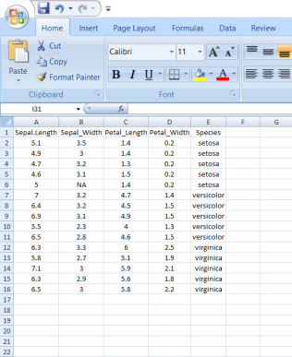

Saving file

I recommend you to save your file in .csv (comma separated value file) format.

How to save as csv

Under the "File name" section in the "Save As" tab, you can select "Save as type" and change it to "CSV (Comma delimited) (*.csv).